1.A) Create & D) ALTER

2.A) Update & B) Delete & C) Select

3.B) Structured Query Language

4.B)Data Defination Language

5.A)Data Manipulation Language

6.C) Create Table A (B int,C float)

7.B) Alter Table A ADD COLUMN D float

8.B) Alter Table A Drop Column D

9.B) Alter Table A Alter Column D int

10.C) Alter Table A Add Primary key B

**ANS 11**. **A data warehouse is a relational database that is designed for query and analysis** rather than for transaction processing. **It usually contains historical data derived from transaction data**, but it can include data from other sources. It separates analysis workload from transaction workload and enables an organization to consolidate data from several sources.

**In addition to a relational database, a data warehouse environment includes an extraction, transportation, transformation, and loading (ETL) solution, an online analytical processing (OLAP) engine**, client analysis tools, and other applications that manage the process of gathering data and delivering it to business users. Data warehouses are optimized to rapidly execute a low number of complex queries on large multi-dimensional datasets. Data warehouses use OnLine Analytical Processing (OLAP) to analyze massive volumes of data rapidly. This process gives analysts the power to look at your data from different points of view.

**Data warehouses provide high-level reporting and analysis that empower businesses to make more informed business. Use cases include:**

**Segmenting customers into different groups based on their past purchases to provide them with more tailored content**

**Predicting customer churn using the last ten years of sales data**

**Creating demand and sales forecasts to decide which areas to focus on next quarter**

**ANS.12**. 1. **An OLTP system captures and maintains transaction data in a database. Each transaction involves individual database records made up of multiple fields or columns. Examples include banking and credit card activity** or retail checkout scanning. **OLAP applies complex queries to large amounts of historical data, aggregated from OLTP databases** and other sources, for data mining, analytics, and business intelligence projects. In OLAP, the emphasis is on response time to these complex queries. Each query involves one or more columns of data aggregated from many rows. **Examples include year-over-year financial performance or marketing lead generation trends**.

2. OLTP **Handles a large number of small transactions**,**OLAP Handles large volumes of data** with complex queries.

3. **OLTP** **uses Simple standardized queries,OLAP uses Complex queries.**

4. **OLAP operations are based on INSERT, UPDATE, DELETE** commands,**OLAP operations based on SELECT commands** to aggregate data for reporting.

5. **OLTP design is Industry-specific**, such as retail, manufacturing, or banking,**OLAP design is subject-specific**, such as sales, inventory, or marketing.

6. **User examples of OLTP include customer-facing personnel, clerks, online shoppers**, **User examples of OLAP include knowledge workers such as data analysts, business analysts, and executives**.

**ANS.13**. There are three prominent data warehouse characteristics:

**Integrated**: The way data is extracted and transformed is uniform, regardless of the original source.

**Time-variant**: Data is organized via time-periods (weekly, monthly, annually, etc.).

**Non-volatile**: A data warehouse is not updated in real-time. It is periodically updated via the uploading of data, protecting it from the influence of momentary change.

Utilizing data warehouses makes it simple to generate reports, run ad-hoc queries and extract near-limitless streams of data that can be converted into meaningful business data.

The data warehouse's greatest strength is getting relevant insight and information into the hands of decision-makers in a timely manner. This enables businesses to keep up with the pace of change, high-competition and digital transformation.

**ANS.14**. **Star schema is the fundamental schema among the data mart schema and it is simplest. This schema is widely used to develop or build a data warehouse and dimensional data marts.** It includes one or more fact tables indexing any number of dimensional tables. The star schema is a necessary case of the snowflake schema. It is also efficient for handling basic queries.

It is said to be star as its physical model resembles to the star shape having a fact table at its center and the dimension tables at its peripheral representing the star’s points. Below is an example to demonstrate the Star Schema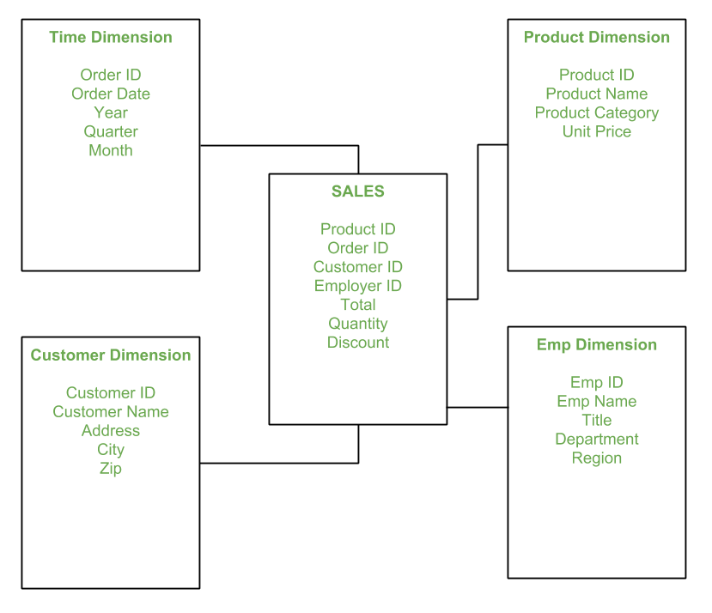

In the above demonstration, SALES is a fact table having attributes i.e. (Product ID, Order ID, Customer ID, Employer ID, Total, Quantity, Discount) which references to the dimension tables. Employee dimension table contains the attributes: Emp ID, Emp Name, Title, Department and Region. Product dimension table contains the attributes: Product ID, Product Name, Product Category, Unit Price. Customer dimension table contains the attributes: Customer ID, Customer Name, Address, City, Zip. Time dimension table contains the attributes: Order ID, Order Date, Year, Quarter, Month

**ANS.15.** **Short for Set Theory as a Language (or Set Language), SETL is a high-level programming language  that's based on the mathematical theory of sets**. It was developed in the early 1970's by mathematician Professor J. Schwartz. SETL is an interpreted language with a syntax that is resembles C  and in many cases similar to Perl. In SETL every statement is terminated by a semicolon. Variable  names are case-insensitive and are automatically determined by their last assignment.